Data

The data in the tables below correspond to the five trials and their respective z-scores. The ‘maximum’ values reflect the value of the accelerating voltage applied at the respective peaks in the image. The error for each data point (z-scores not included) and the averages are +/- .001 volt per the accuracy of the Keithley Sourcemeter. There is a ‘critical value’ at about 53.5V where a spike in the graph happens. This is the end of the available peaks to be measured. We start at ~20V when recording data because there were no clear peaks before this point.

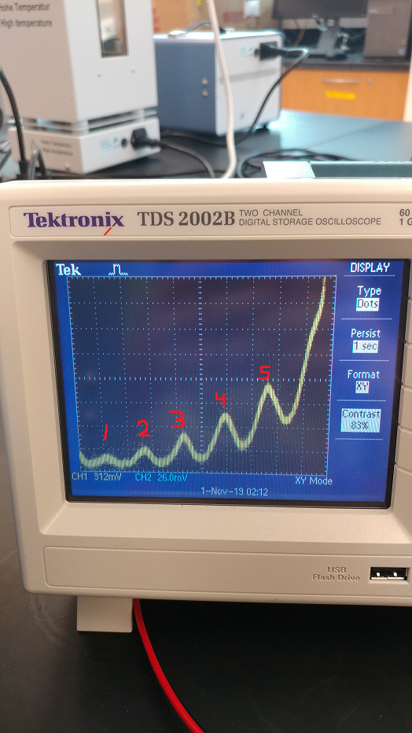

|  |  |  |  |  |
| --- | --- | --- | --- | --- |
| **Scale - Volts** | **First Max** | **z-score 1** | **Second Max** | **z-score 2** |
| Trial 1 | 21.136 | -1.037330096 | 26.273 | 0.716885973 |
| Trial 2 | 21.227 | 0.035363526 | 26.158 | -0.276389773 |
| Trial 3 | 21.195 | -0.341847418 | 26.289 | 0.85508086 |
| Trial 4 | 21.338 | 1.343813988 | 26.04 | -1.29557706 |
| Average | 21.224 |  | 26.19 |  |
| Error = +/- .001 |  |  |  |  |

|  |  |  |  |  |  |
| --- | --- | --- | --- | --- | --- |
| **Third Max** | **z-score 3** | **Fourth Max** | **z-score 4** | **Fifth Max** | **z-score 5** |
| 31.355 | -0.756230592 | 36.762 | 0.774065379 | 41.989 | -1.059814245 |
| 31.34 | -0.917130718 | 36.628 | -0.047516885 | 42.315 | 0.742008148 |
| 31.475 | 0.530970416 | 36.745 | 0.669834793 | 42.065 | -0.639757491 |
| 31.532 | 1.142390894 | 36.408 | -1.396383287 | 42.354 | 0.957563588 |
| 31.426 |  | 36.636 |  | 42.181 |  |

Analysis

The difference between peaks on average is ~5.23 +/- .001V. This value increased as the accelerating voltage was increased. The average difference between peaks 1 and 2 is 4.966V, peaks 2 and 3 -5.236V, peaks 3 and 4 - 5.21V, and the average difference between peaks 4 and 5 is 5.545V. The value of accelerating voltage at each respective peak through all the trials remained “random” and did not increase with any pattern. A reverse bias of -1.1V was applied to create more clear data, but this is not likely the cause for a linear increase in the difference. There were reported issues involving collecting data at higher accelerating voltages (though these issues were most likely involved with the second systematic error mentioned next). This particular error seems to be caused by some unexplained systematic error not easily discovered by simply taking data many times over; but the pattern is clear.

There is a random error in that the accelerating voltage could only be increased in increments of 0.5V. While the actual value of accelerating voltage could be read on the Keithley down to an error of +/- .001V, the value at each peak was not perfectly consistent through each trial because of the sensitivity of the knob. In other words, each time a particular peak was revisited, the corresponding accelerating voltage could change by as much as 0.3V between trials. This error did not cause any major issues in the data as the z-scores of each value with respect to the averages are reasonable.

A systematic error in the data was not removed because the error does not change the difference between each peak. This issue involves the contact bias between the material inside (not the mercury vapor) being heated to release electrons, and the material involved in the collection process. This caused a permanent value of -0.43V to be applied to each value.

Conclusion

While the average difference between each peak was quite high, the change in this difference increased linearly with increased accelerating voltage and seemed to be caused by an unknown systematic error. The average differences between each peak up to peak 4 were within 0.35V of the accepted value of 4.9V.

It would be interesting to have the option to continue to increase the accelerating voltage beyond 42V to see if the difference between peaks would continue to increase. But the ‘cut-off’ issue stems from the amount of space the electrons have to come in contact with mercury (i.e. we believe the length of the ‘box’ would need to be increased).

The other way to improve the data collection method, and maybe more practical, would be to allow for more fine-tuned adjustment of the accelerating voltage. But this would involve improvements to the instrument itself.